Assignment 7:

Team Details:

Kiran Tej Badana

Akhilesh Kalaru

Naveen Kumar Sheela

We have implemented the below mentioned list of queries.

1. Select all features completely contained within R
2. Select all features that are in contact with R.
3. Display all items within r distance from P. Draw a circle around this area.

Execution steps for getting the relevant output information.

1. Make two clicks on the map to display the rectangle and select the query to be executed from the list and click on submit to display the information with in the rectangle.(Enter 1 in the text box)

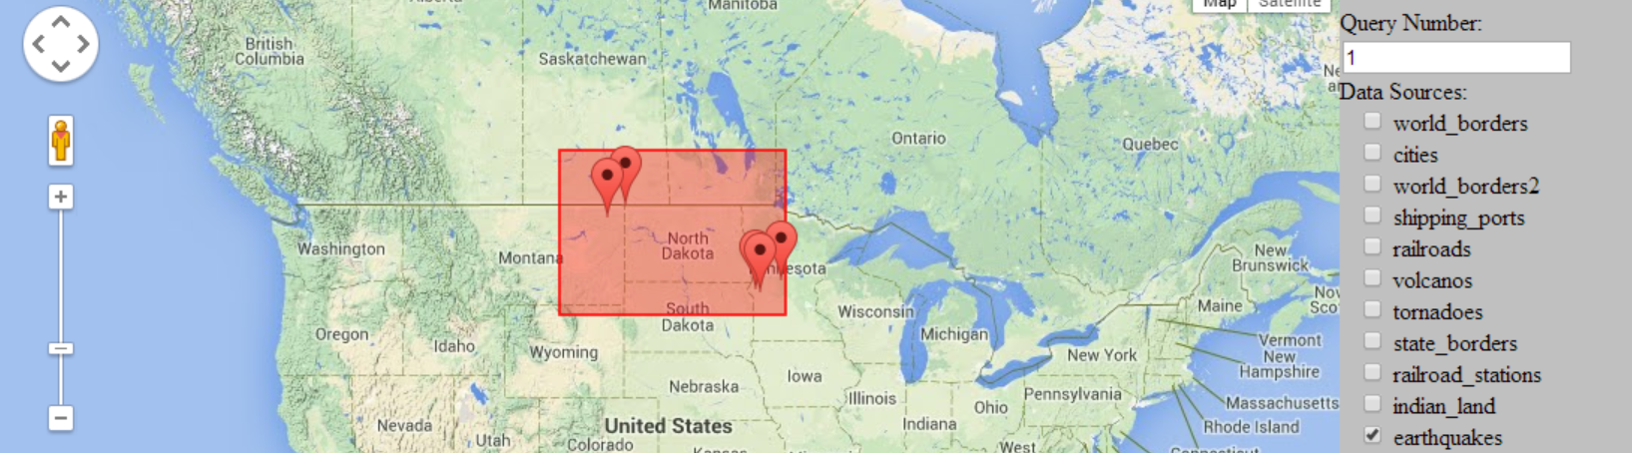

1. Make two clicks on the map to display the rectangle and select the query to be executed from the list and click on submit to display the information with in the rectangle. Select the rail road to display the railway information. (select 2 in the textbox and select state rail roads and click on submit)

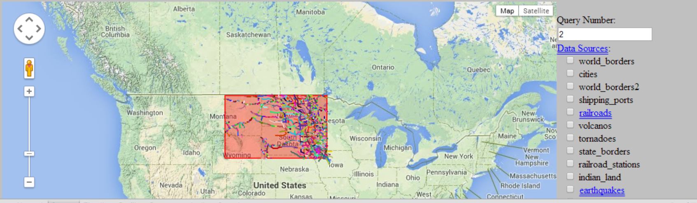

We have used ST_Touch function which is not working so we have used ST_Intersects.

1. Provide 5 in the textbox first and make two clicks for creating the circle. And click submit to display the information.

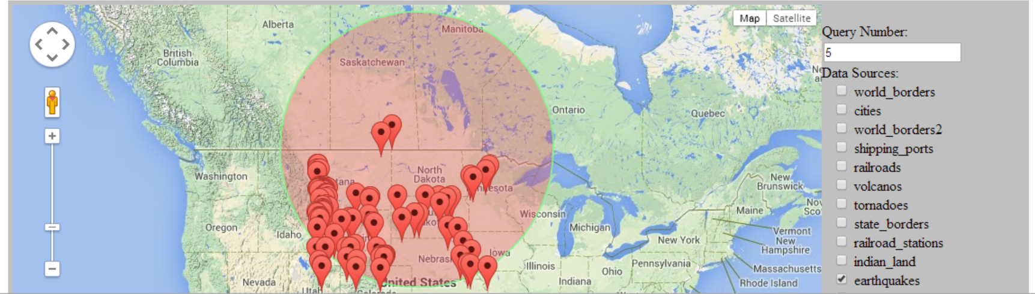

Caution : Enter the text box value first before clicking on the map.